1. Tcode SMARTFORMS and create a new SMARTFORM with Z/Y name by clicking on Click button
2. Click on the form interface and then Import tab to declare 2 variables of type I

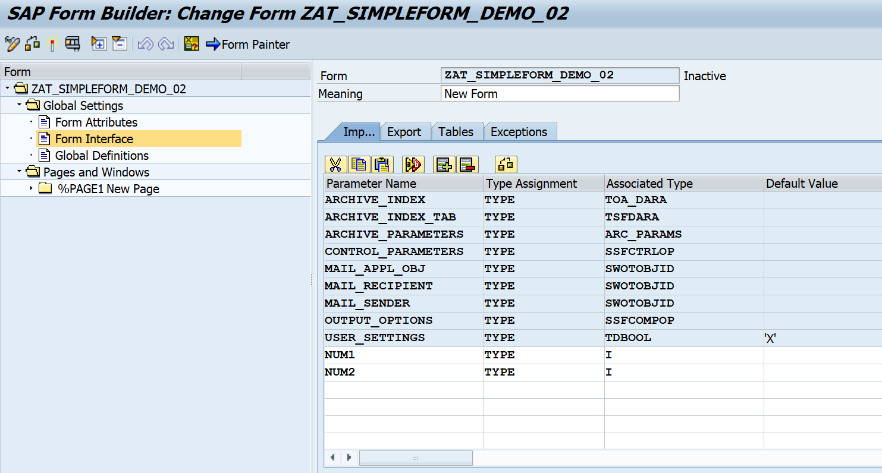

1. Click on Export tab to declare SUM variable of type I

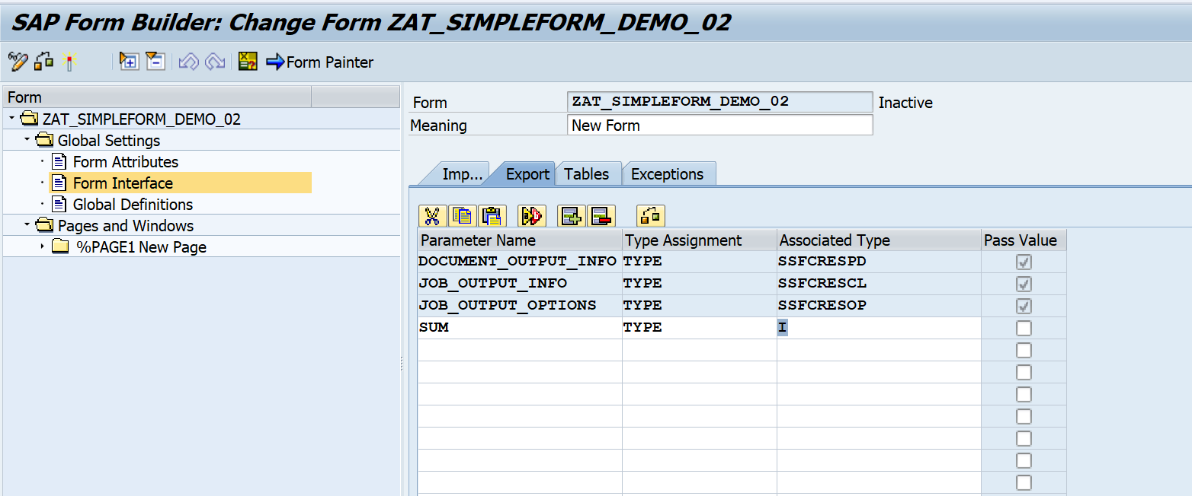

1. Go to Main Window in Pages and Windows Folder and right click on it to get flow logic and further Program Lines.

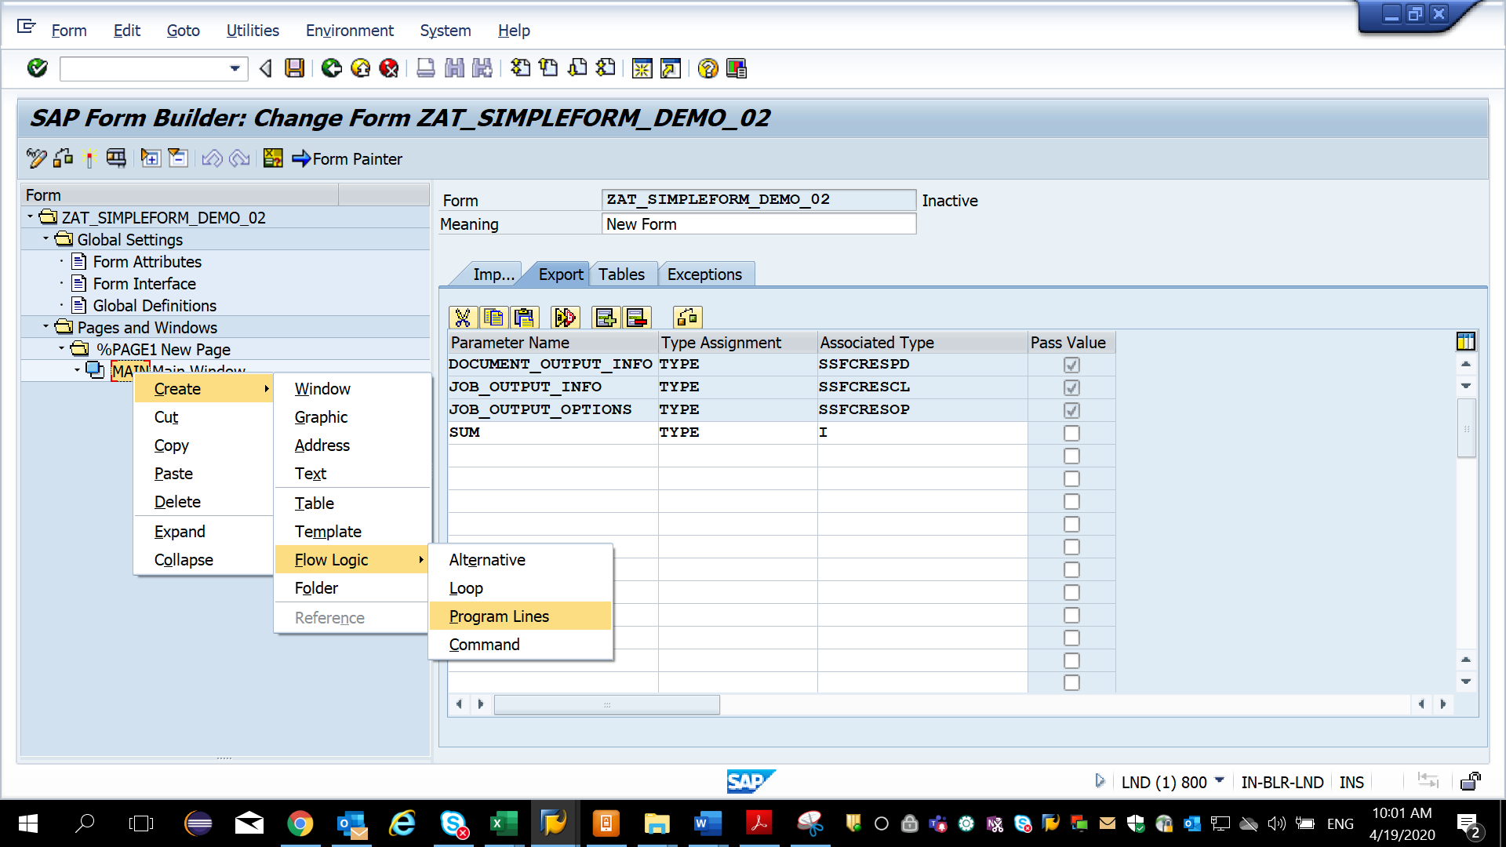

1. Provide the input and output parameters and write the code in the editor section.

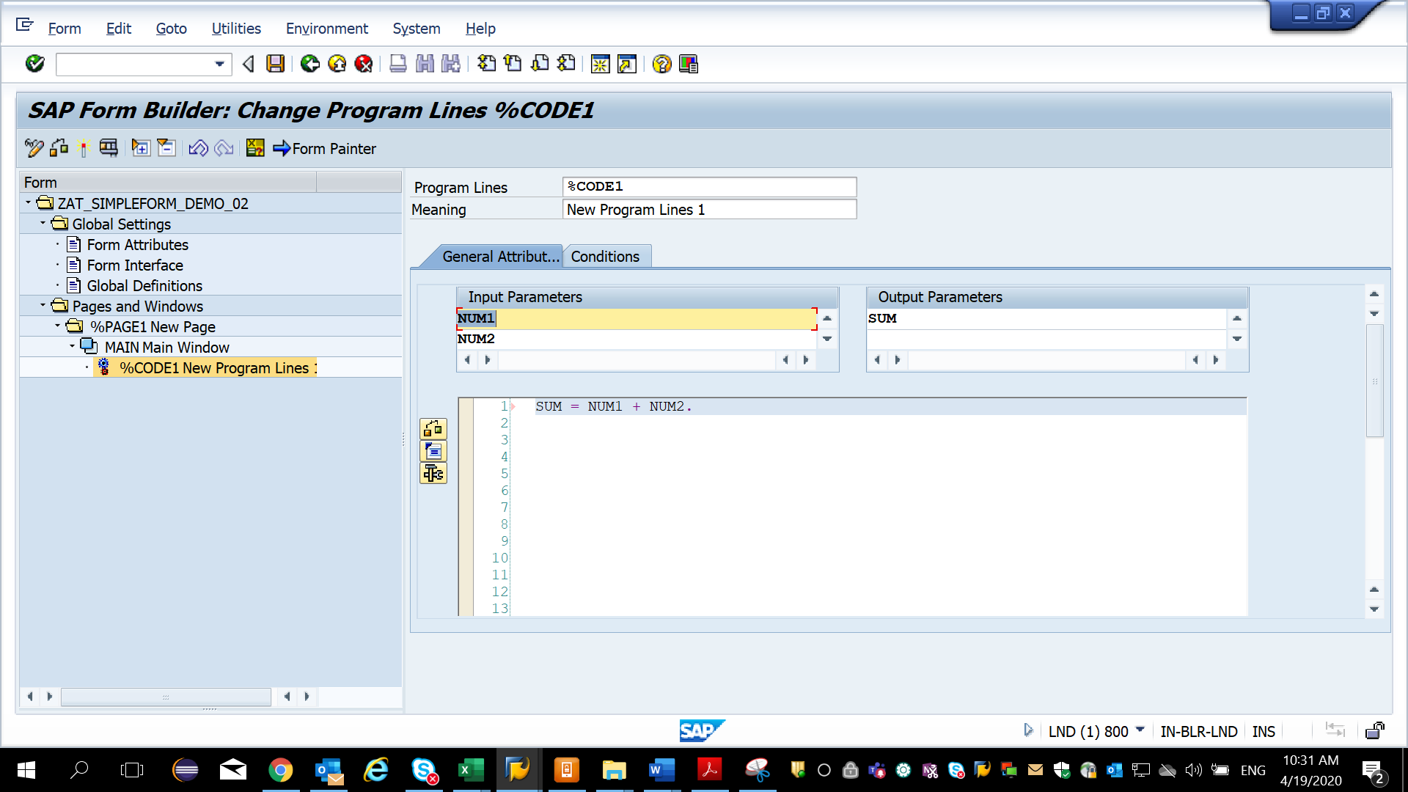

1. To print the results, right click on Main window and select Text

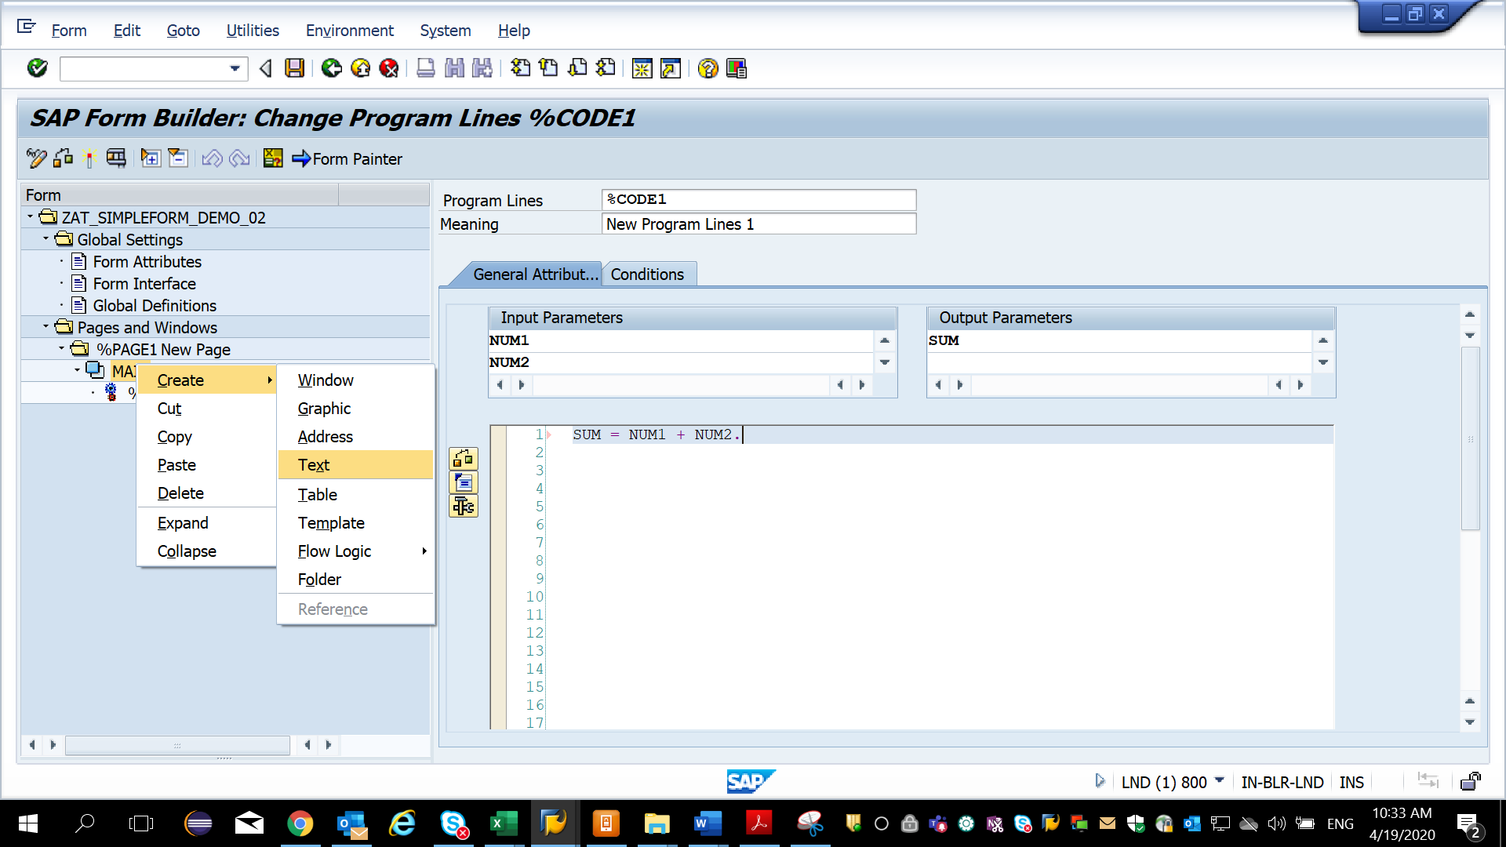

1. Write the statement to be printed in the output. Ensure the text window is after the program lines window else the result wont be shown in the output.

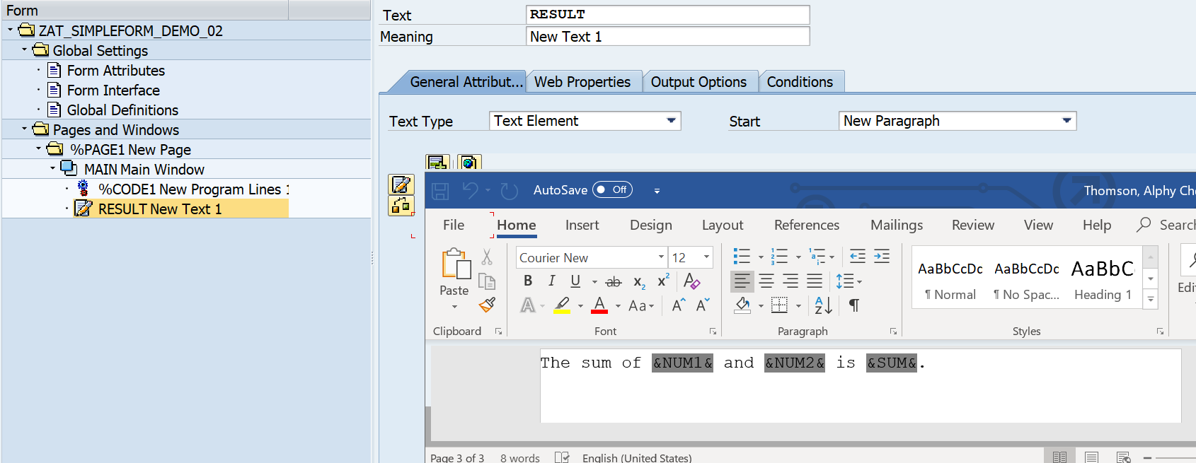

8) save, activate, execute - the functional module and then provide the nos and check the output in print preview.

